**Mastering Embedded System**

**Online Diploma**

[**www.learn-in-depth.com**](http://www.learn-in-depth.com)



**First Term**

**(Final Project 1)**

**“ Pressure Controller ”**

**Eng.** [**Khaled El-Sayed**](https://www.learn-in-depth.com/online-diploma/t0ti20%40icloud.com)

**CONTENT:**

* **Case Study.**
* **Method.**
* **Requirements Diagram.**
* **Space Exploration.**
* **System Analysis.**
* **System Design.**



[**+20 (100) 303-1049**](tel://+201003031049/)

[**t0ti20@icloud.com**](mailto:t0ti20@icloud.com)

**Mansoura, Dakahlia, Egypt**

* **Case Study.**
* **Main Idea**

A client expects you to deliver the software of the following system:

* Specification (from the client)
* A pressure controller informs the crew of a cabin with an alarm when the pressure exceeds 20 bars in the cabin.
* The alarm duration equals 60 seconds.
* **Assumptions**

1. Set up and Shutdown Procedures: The software system does not include modeling or simulation of the controller's set up and shutdown procedures.
2. Controller Maintenance: The software system does not incorporate modeling or simulation of the maintenance procedures for the controller.
3. Pressure Sensor Reliability: The assumption is made that the pressure sensor used in the system never fails and consistently provides accurate readings.
4. Alarm Reliability: It is assumed that the alarm used in the system never fails and functions reliably to notify the crew when the pressure exceeds the specified threshold.
5. Power Continuity: The assumption is that the controller never experiences power cuts or interruptions, ensuring uninterrupted operation of the system.

* **Method**

Agile Scrum methodology can be beneficial for developing This project in the following ways, considering the client's expectations:

* Flexibility and Adaptability: Agile Scrum allows for flexibility in handling changing requirements. In embedded software development, client requirements may evolve as they gain a better understanding of the system or encounter new needs during the development process. Agile Scrum enables the team to adapt quickly, accommodating changes and ensuring that the final software meets the client's expectations.
* Incremental Development: The iterative nature of Agile Scrum lends itself well to embedded software development. By breaking the project into smaller increments, called sprints, the team can focus on developing and delivering specific functionalities within short time frames. This approach allows for frequent testing, validation, and feedback, leading to better-quality software.
* Early and Continuous Testing: In embedded software, it is essential to ensure seamless integration with hardware components and reliability in real-world scenarios. Agile Scrum promotes continuous testing throughout the development process. By regularly integrating software with hardware and conducting tests, any issues or bugs can be identified and addressed early, resulting in a more stable and robust system.
* Client Involvement: Agile Scrum encourages client involvement throughout the development cycle. By actively engaging the client in the process, through regular reviews, feedback sessions, and demos, the team can ensure that the software aligns with the client's expectations and meets their specific needs.
* Faster Time-to-Market: Agile Scrum's iterative approach, coupled with its focus on delivering working software increments, can accelerate the time-to-market for embedded software projects. By delivering valuable functionality in each sprint, the team can release usable software to the client earlier, gaining a competitive edge or addressing time-sensitive needs.

Ultimately, the choice to use Agile Scrum methodology for embedded software development should consider project-specific factors, team dynamics, and client preferences. However, the benefits outlined above make Agile Scrum a popular and effective approach in delivering high-quality embedded software that meets client expectations.

* **Requirements Diagram.**

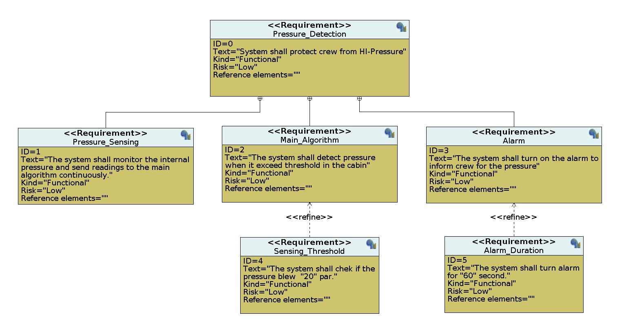

**• Space Exploration.**

choosing an STM32 microcontroller for the pressure controller system offers the following advantages:

• Robustness and reliability in harsh environments.

• High performance for real-time processing of pressure measurements and alarms.

• Rich integration of built-in peripherals simplifies hardware design and interfacing.

• Extensive software with development tools, libraries, and community support.

• Cost-effectiveness compared to other microcontroller options with same capabilities.

Overall, the STM32 microcontroller provides a reliable, high-performance, and cost-effective solution that meets the client's expectations for the pressure controller system.

**• System Analysis.**

* **Use Case Diagram**

* **Activity Diagram**

* **Sequence Diagram**

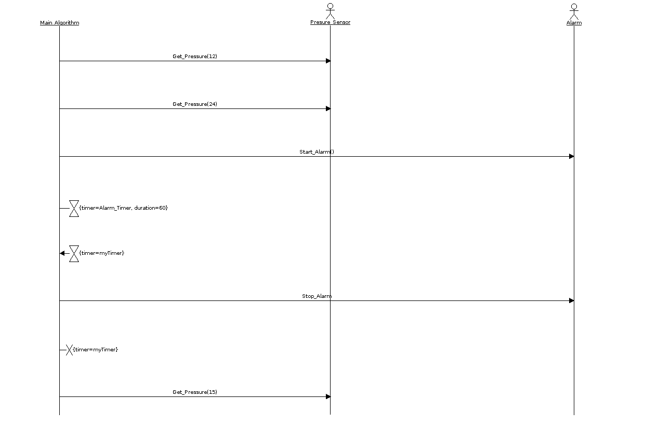

**• System Design.**

* **Block Diagram**

* **State Machine Diagram**

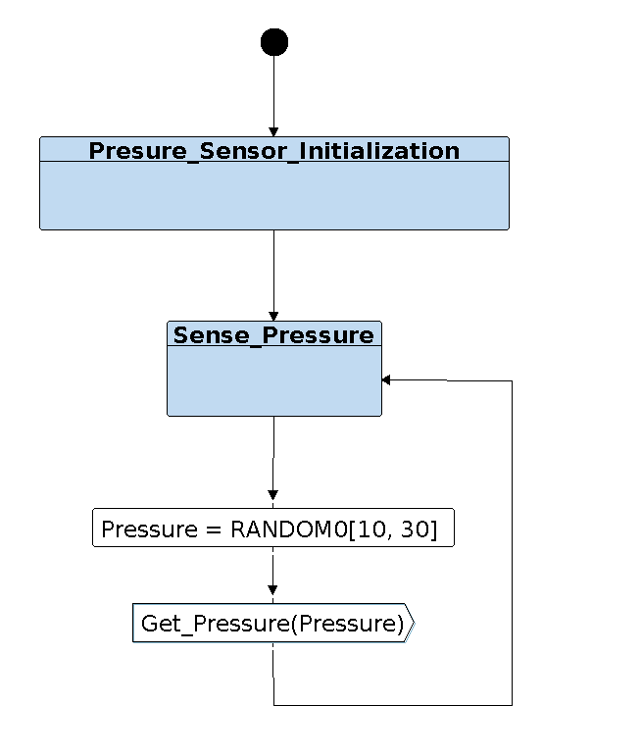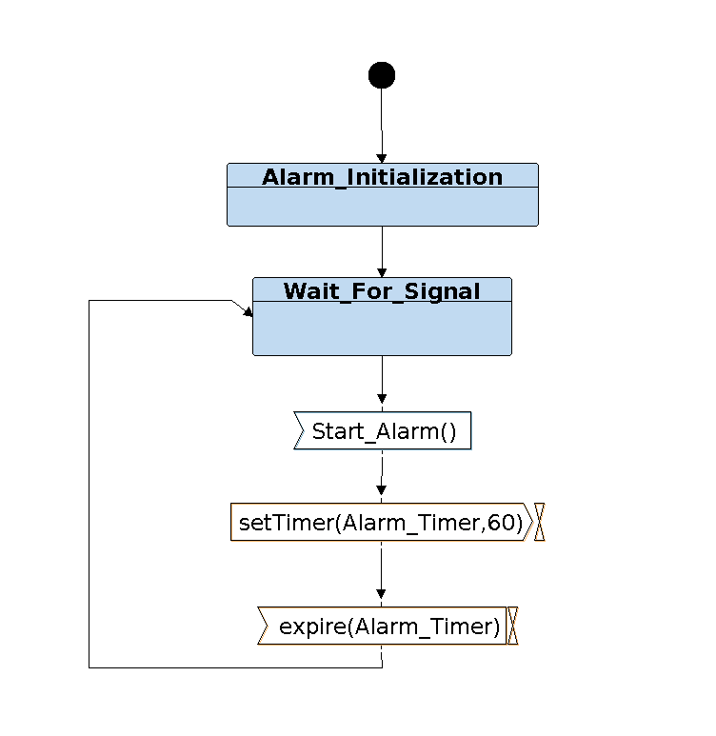

* **Sequence Diagram**

